GURUDEV INTERNATIONAL PUBLIC SCHOOL KAYDI,BALAGHAT

CLASS - II

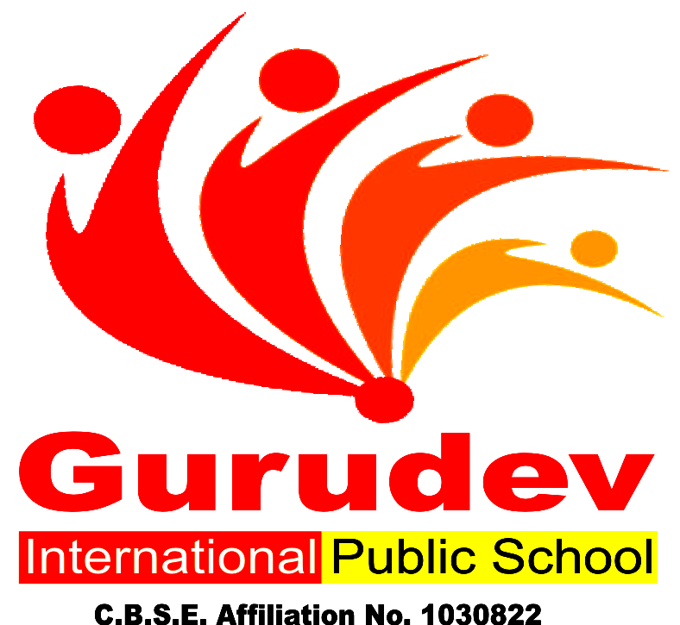

GURUDEV INTERNATIONAL PUBLIC SCHOOL KAYDI,BALAGHAT

A Building with Four Walls And Tomorrow Inside.

Dear Parents,
Summer holidays have begun and it’s time for fun, frolic for kids. While fun is intrinsic to their age, constructive activities and fruitful occupation of their time is of vital importance. It paves the way towards a bright future for the child and a progressive learning graph.
Some Pointers: -
Free play time should alternate with structured games-this cultivates sportsmanship.
Assign a permanent workplace and a work time this brings in a system and discipline into the child’s life.
Inculcate good manners, healthy habits and respect for elders.
Never ever compare or hurt their pride as it will stunt their confidence.
We are giving a short assignment for the vacation. We have tried to make the work enjoyable keeping in mind their interest. Space out the work &the child will enjoy doing it. Wishing all of you a very enjoyable and fun-packed Summer break.

GURUDEV INTERNATIONAL PUBLIC SCHOOL KAYDI,BALAGHAT
HAPPY HOLIDAYS

HOLIDAY HOMEWORK SUMMER VACATION
Session 2019 – 2020

Name: Class: II Date: / / Subject: Math

  - Write Number Name the given numbers:
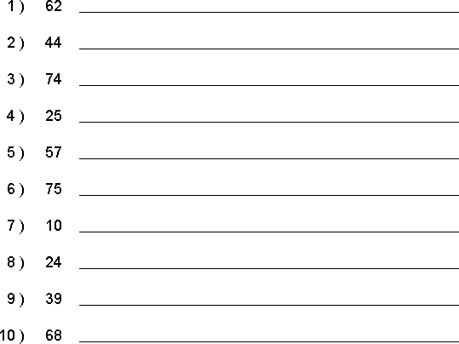

Complete the given worksheets.
- Learn and write tables from 2- 10 in a separate thin notebook.

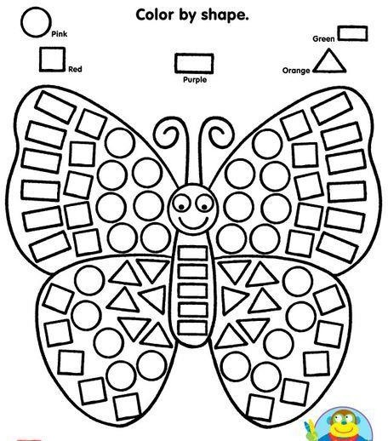

HOLIDAY HOMEWORK SUMMER VACATION
Session 2019 – 2020

Name: Class: II
Date: / / Subject: English

Q.1 Write the name of things you see only at night in the sky.

Q.2 Write the name of the things which we use in Rainy season and paste the pictures.

Q.3 Write five pages in cursive handwriting.

HOLIDAY HOMEWORK SUMMER VACATION
Session 2019 – 2020

Name: Class: II
Date: / / Subject: EVS

1. Write 10 sentences about yourself.
2. Write the name of Body parts (any 15).
Project
3. Paste some internal organ pictures in a project paper like. Brain, Lungs, Heart , Kidneys , Stomach and write about their functions.
4. Answers the following question.
a) What do you understand by the term Hobby .
b) Why should we develop Hobbies .
HOLIDAY HOMEWORK SUMMER VACATION
Session 2019 – 2020

Name: Class: II
Date: / / Subject: Hindi

1- Loj o O;atu fyf[k,A
2- vH;kl 1 o 2 ] dfork dh iafDr;k fy[kdj ;kn djukA
3- “kCnkFkZ ] iz”uksRrj ;kn djsA

HOLIDAY HOMEWORK SUMMER VACATION
Session 2019 – 2020

Name: Class: II
Date: / / Subject: Computer

Paste the picture:-
1. Monitor
2. Mouse
3. Keyboard
4. Printer
5. CPU
6. CD

