GURUDEV INTERNATIONAL PUBLIC SCHOOL KAYDI,BALAGHAT

CLASS - VII

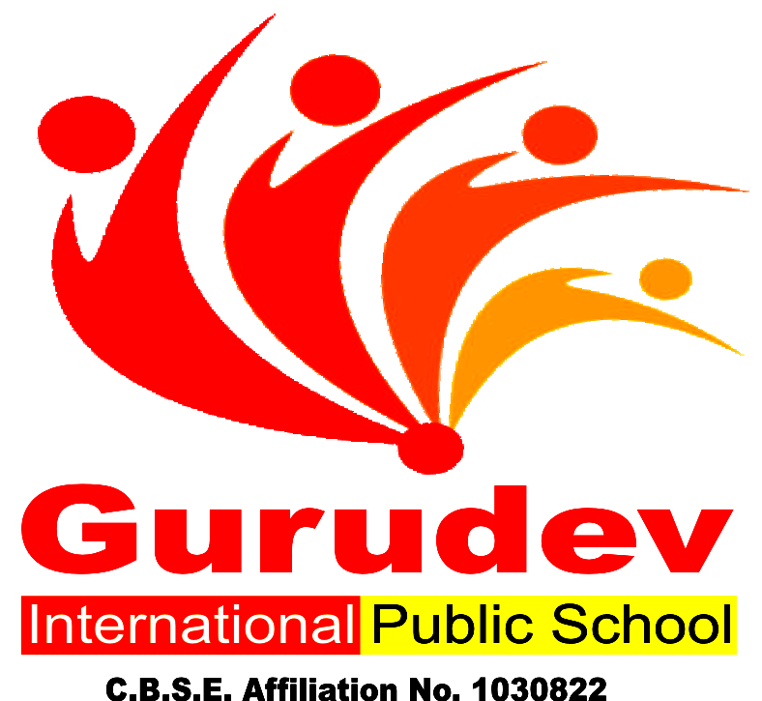

GURUDEV INTERNATIONAL PUBLIC SCHOOL KAYDI,BALAGHAT

A Building with Four Walls And Tomorrow Inside.

Dear Parents,
Summer holidays have begun and it’s time for fun, frolic for kids. While fun is intrinsic to their age, constructive activities and fruitful occupation of their time is of vital importance. It paves the way towards a bright future for the child and a progressive learning graph.
Some Pointers: -
Free play time should alternate with structured games-this cultivates sportsmanship.
Assign a permanent workplace and a work time this brings in a system and discipline into the child’s life.
Inculcate good manners, healthy habits and respect for elders.
Never ever compare or hurt their pride as it will stunt their confidence.
We are giving a short assignment for the vacation. We have tried to make the work enjoyable keeping in mind their interest. Space out the work &the child will enjoy doing it. Wishing all of you a very enjoyable and fun-packed Summer break.

GURUDEV INTERNATIONAL PUBLIC SCHOOL KAYDI,BALAGHAT
HAPPY HOLIDAYS

HOLIDAY HOMEWORK SUMMER VACATION Session 2019 – 2020

Name: Class: VII
Date: / / Subject: English

Books can be a lot of fun as they not only entertain you but also take you places and help in broadening your outlook. Read any ONE of the books suggested in the list. You already have these books as a part of long reading text exercise. So get going and indulge in the delight of reading…
- Heidi
- Alice in Wonderland
a. Which is your favourite character from the book which you have read? Write your answer describing the character. Use rich vocabulary from the book you have read. (50 words)
Find any five words from the story and make a word map based on the format given
WORD MAP:
Word……………………………………….
Dictionary Meaning ……………………………………………………………………………………………….
Antonym | Synonym
Sentence

STORY REVIEW
Title:
Author:
Setting:

Characters: _

Problem:

Solution

My opinion: I liked this story
because

HOLIDAY HOMEWORK SUMMER VACATION Session 2019 – 2020

Name: Class: VII
Date: / / Subject: MATHS

  - Draw lines of Symmetry on each shape. Count and write the lines of symmetry you see.
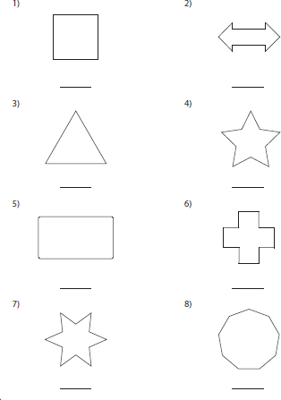

  - Lattice multiplication method ( example is given ):

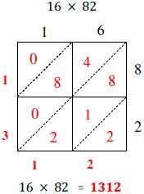 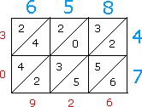 6 5 8 × 4 7 = 3 0 9 2 6
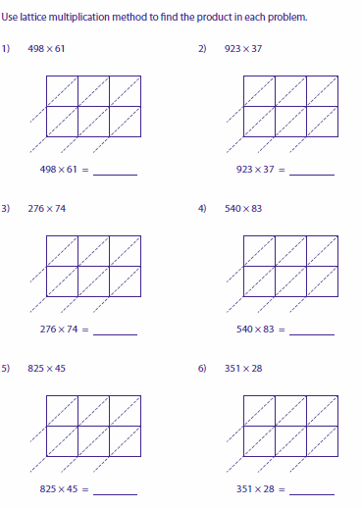
HOLIDAY HOMEWORK SUMMER VACATION Session 2019 – 2020

Name: Class: VII
Date: / / Subject: Sanskrit

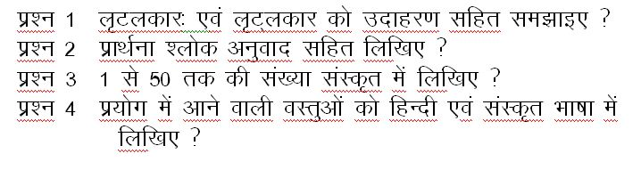

HOLIDAY HOMEWORK SUMMER VACATION
Session 2019 – 2020

Name: Class: VII
Date: / / Subject: Hindi

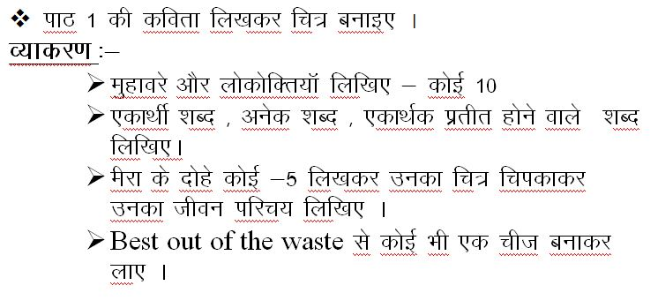

HOLIDAY HOMEWORK SUMMER VACATION Session 2019 – 2020

Name: Class: VII
Date: / / Subject: Science

1. Draw the Diagram:-
A. Paramecium Uses Its Cilia To Take Its Food.
B. Make A Chart:-Digestive System in Humans
C. A Permanent Set of Teeth of Humans
2. Write One Paragraph about Human Digestive System
3. Write 3 – 4 Lines About Temporary And Permanent Teeth.

HOLIDAY HOMEWORK SUMMER VACATION Session 2019 – 2020

Name: Class: VII
Date: / / Subject: S.S.T

Make Project work on medieval India Including following points.

1. Visiting the part
2. India and its different Names
3. Importance of medieval History
4. Sources
5. Historians and this sources
6. Archeological sources
7. Literary sources.

