GURUDEV INTERNATIONAL PUBLIC SCHOOL KAYDI,BALAGHAT

CLASS - VIII

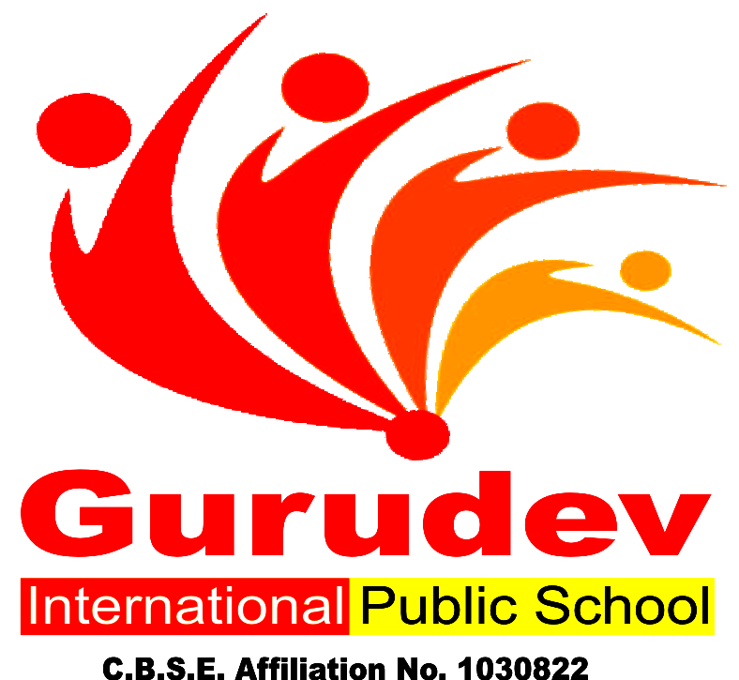

GURUDEV INTERNATIONAL PUBLIC SCHOOL KAYDI,BALAGHAT

A Building with Four Walls And Tomorrow Inside.

Dear Parents,
Summer holidays have begun and it’s time for fun, frolic for kids. While fun is intrinsic to their age, constructive activities and fruitful occupation of their time is of vital importance. It paves the way towards a bright future for the child and a progressive learning graph.
Some Pointers: -
Free play time should alternate with structured games-this cultivates sportsmanship.
Assign a permanent workplace and a work time this brings in a system and discipline into the child’s life.
Inculcate good manners, healthy habits and respect for elders.
Never ever compare or hurt their pride as it will stunt their confidence.
We are giving a short assignment for the vacation. We have tried to make the work enjoyable keeping in mind their interest. Space out the work &the child will enjoy doing it. Wishing all of you a very enjoyable and fun-packed Summer break.

GURUDEV INTERNATIONAL PUBLIC SCHOOL KAYDI,BALAGHAT
HAPPY HOLIDAYS

HOLIDAY HOMEWORK SUMMER VACATION
Session 2019 – 2020

Name: Class: VIII
Date: / / Subject: English

Explain following figure of speech with example.

1. Simile
2. Personification
3. Metaphor
4. Alliteration

HOLIDAY HOMEWORK SUMMER VACATION Session 2019 – 2020

Name: Class: VIII
Date: / / Subject: Science

1. Make Chart: -
A. Agricultural Practices
B. Immunisation Shedule in India
C. Common Diseases Caused By Microorganism in Humans and Animals.
2. Write one Practical:- To Separate Good and Healthy Seeds From Damaged {Unhealthy Ones}

HOLIDAY HOMEWORK SUMMER VACATION Session 2019 – 2020

Name: Class: VIII
Date: / / Subject: S.S.T

1.Make Project work on Understanding Modern Indian History Including all important points.

HOLIDAY HOMEWORK SUMMER VACATION
Session 2019 – 2020

Name: Class: VIII
Date: / / Subject: Hindi

HOLIDAY HOMEWORK SUMMER VACATION
Session 2019 – 2020

Name: Class: VIII
Date: / / Subject: SANSKRIT

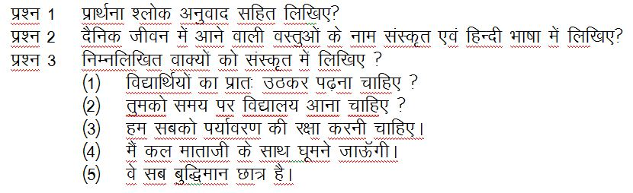

HOLIDAY HOMEWORK SUMMER VACATION Session 2019 – 2020

Name: Class: VIII
Date: / / Subject: Math

