GURUDEV INTERNATIONAL PUBLIC SCHOOL KAYDI,BALAGHAT

CLASS - X

GURUDEV INTERNATIONAL PUBLIC SCHOOL KAYDI,BALAGHAT
A Building with Four Walls And Tomorrow Inside.

Dear Parents,
Summer holidays have begun and it’s time for fun, frolic for kids. While fun is intrinsic to their age, constructive activities and fruitful occupation of their time is of vital importance. It paves the way towards a bright future for the child and a progressive learning graph.
Some Pointers: -
Free play time should alternate with structured games-this cultivates sportsmanship.
Assign a permanent workplace and a work time this brings in a system and discipline into the child’s life.
Inculcate good manners, healthy habits and respect for elders.
Never ever compare or hurt their pride as it will stunt their confidence.
We are giving a short assignment for the vacation. We have tried to make the work enjoyable keeping in mind their interest. Space out the work &the child will enjoy doing it. Wishing all of you a very enjoyable and fun-packed Summer break.

GURUDEV INTERNATIONAL PUBLIC SCHOOL KAYDI,BALAGHAT
HAPPY HOLIDAYS

HOLIDAY HOMEWORK SUMMER VACATION
Session 2019 – 2020

Name: Class: X
Date: / / Subject: S.S.T

1. Complete Project work on the Rice of Nationalism in Europe. Cover entice points.

HOLIDAY HOMEWORK SUMMER VACATION
Session 2019 – 2020

Name: Class: X
Date: / / Subject: Hindi

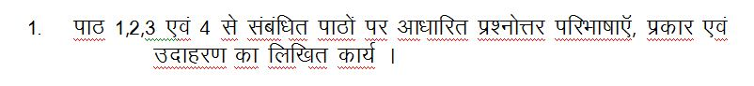

HOLIDAY HOMEWORK SUMMER VACATION
Session 2019 – 2020

Name: Class: X
Date: / / Subject: English

Describe the pros and cons of the following subjects:-
- Making global friendship through the Internet.
- Hand Industries.

HOLIDAY HOMEWORK SUMMER VACATION
Session 2019 – 2020

Name: Class: X
Date: / / Subject: Math

1. Create 7 Problems from environment related to linear equation in two variables and solve them.
2. Prepare a formula chart from algebraic chapters (boys) and geometric Chapters (Girls).

HOLIDAY HOMEWORK SUMMER VACATION
Session 2019 – 2020

Name: Class: X
Date: / / Subject: Science

1. Plot graph for ohm’s law and series and parallel combination of resistors ?
2. Make a table for different types of material of Resistivity for conductor ,alloys, insulator .
3. Find the Resistance of given following circuit between X and Y.

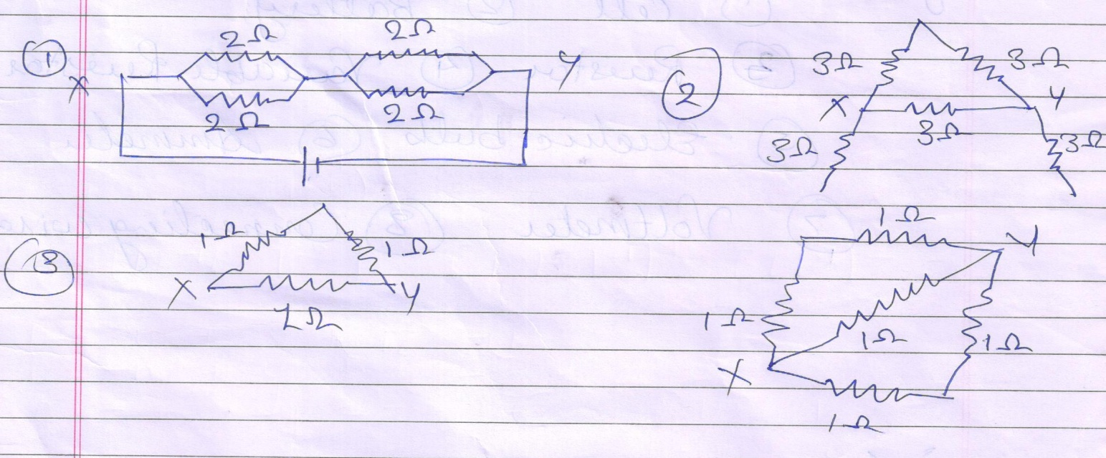

4. A wire is connected between the point P and Q in the circuit to carry a current I. if it is replaced by a wire of .
a) Same Length and half thickness
b) Half length and same thickness, how will the Current vary?

5. Two resistors of 8Ω and 12 Ω are connected in parallel. The combination is connected across a 10 V battery of negligible resistance. Calculate.

a) The current through the battery.
b) The current through each resistor.
6. Make circuit symbol of following given .
a) Cell b) Battery c) Resistor d) Variable resistor e) Electric bulb f) Ammeter g)Voltmeter h) connecting wire.

